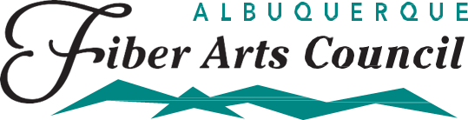
Fiesta 2021
Call for Entries
Due March 1, 2021
Beadwork
Sponsored by:
The New Mexico Bead Society
A bead is defined as a small piece of glass, stone, or similar material, typically rounded and perforated for threading.
Judged with Cash Awards. Each category includes two monetary awards of $50 1st place, $25 Runner-Up for a total of $75 per category.
Betty Whiteman Best of Show Award: $50

Open to All
B101: All bead embroidery entries made using backing and stiffening
B102: Woven bead entries made both off and on loom, including kumihimo
B103: Beaded entries featuring beads MADE by the artist (minimum 50% components)
B104: Beaded entries featuring beads NOT made by the artist.
B105: Beaded non-jewelry (home décor and clothing) items (beads must comprise 50% of the Item)
B106: Metal jewelry items including chain mail and wire work (wire/metal must comprise 50% of the item
B107: Not Judged: Beadwork by youth 12 years or under as of March 1, 2021
B108: Not Judged: Beadwork by youth 13- 18 years of age.

RULES FOR SUBMISSION OF
BEADWORK
- Work must have been completed by entrant after March 1, 2019.

- Please label each piece with your name, address and the title of the piece.

- All entries must be finished and ready to display.

- The jury in each division and/or the Exhibition Committee reserves the right to reclassify an entry into another division and/or category when deemed appropriate based upon the description and photo(s) submitted on the Fiesta Entry Form.

- Entries may not be removed from display until Fiesta closes. Professional Security is provided during Fiesta off-hours/overnight.

